

ISTANBUL TECHNICAL

**0**

**1**

UNIVERSITY

COMPUTER ENGINEERING

DIGITAL CIRCUITS LABORATORY

EXPERIMENT REPORT

EXPERIMENT NO: 9

EXPERIMENT NAME: SERIAL ARITHMETIC LOGIC UNIT

EXPERIMENT DATE : 26.04.2013

GROUP NO: 6

STUDENTS WHO DID THE EXPERIMENT:

Student no Name Surname

**040100113 MUSTAFA UÇAR**

**040100117 TUĞRUL YATAĞAN**

040100124 EMRE GÖKREM

ASSISTANT NAME WHO ASSISTED THE EXPERIMENT: MEHMET TAHİR SANDIKKAYA

1- )

a)

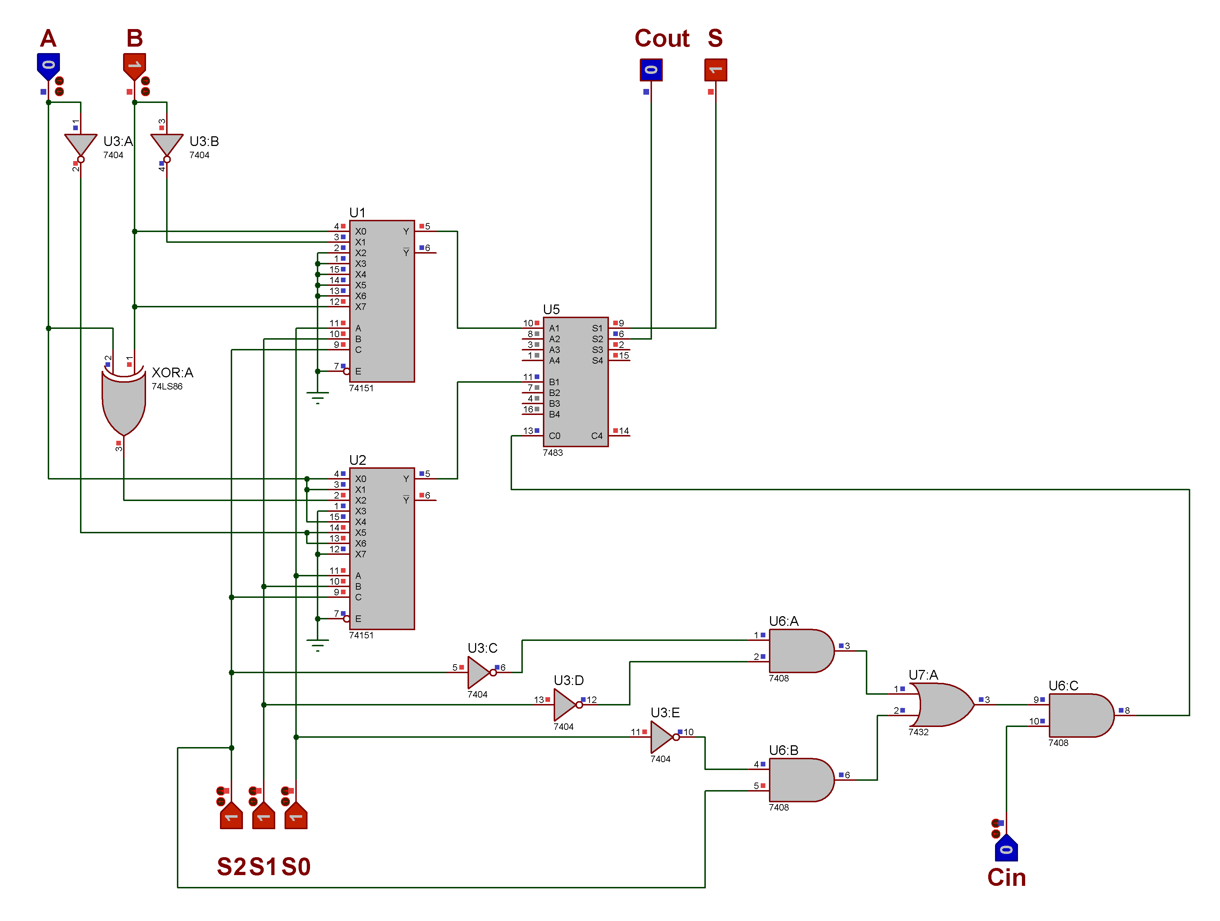

b)

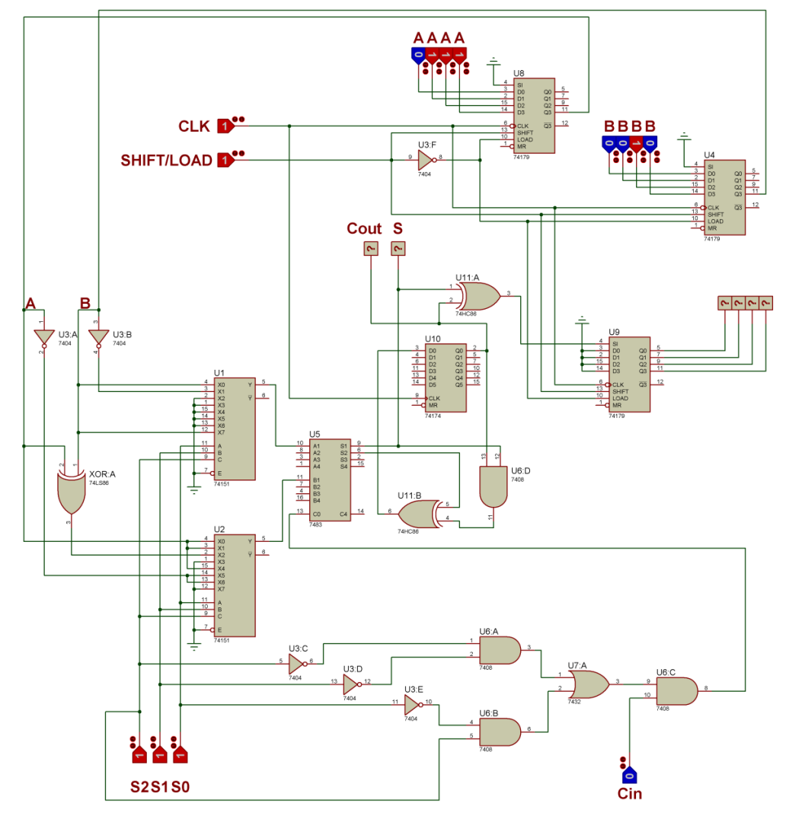

**2- )**

